**QTM 151 Final Project**

# Grading Criteria:



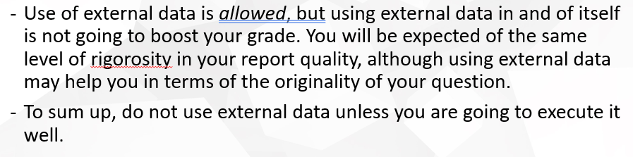

# 3 Main Questions

Question 1: Compare various countries’ rights to death penalty execution (dpex) and the right to participate in government, and their overall freedom from torture **tort, dpex and polplart**, in **HRMI Civil and Political Rights (CPR) dataset.**

Question 2: (2018 only) Compare various countries’ rights to form unions and their rights to favourable work conditions. **jobcond and union in HRMI People at Risk (PaR) Dataset**

Question 3: Compare changes in **FoodSecure** and changes in **BasicSanitation**, in **HRMI Economic and Social Rights (ESR) Dataset**

## Possible Questions (brainstorm):

* Compare the level of rights of different countries with respect to country age or type of government model.
* Compare US to rest of the world
* Compare the amount of arrests of different countries
* Compare changes in **FoodSecure** and changes in **BasicSanitation**, in **HRMI Economic and Social Rights (ESR) Dataset**
* Compare changes in **physint** to changes in **empower,** in **HRMI Civil and Political Rights (CPR) Dataset**
  + physint = Overall right to safety from the state, i.e. Physical Integrity Right
    - Based on scores for arrest (Right to freedom from arbitrary or political arrest and imprisonment), disap (Right to freedom from disappearance), dpex (Right to freedom from death penalty execution), exkill (), and tort ()
  + empower = Overall right to empowerment
    - Based on scores for assem, express, polpart , and rel
  + 1 country, year by year -> find a country with data
* (2018 only) Compare various countries’ rights to form unions and their rights to favourable work conditions. **jobcond and union in HRMI People at Risk (PaR) Dataset**
* Compare rights to freedom from from death penalty execution (**dpex**) for counties under dictatorship rule and those that have not in HRMI Website Data Set
  + Other types of gov (similar to dictatorship rule)